Math Attachment Week # 8
Math Game of the Week- (2 Options)
OPTION A-Catch the Monkeys 7,8,9Times Table Practice with a partner
You need: Game board, 2 different colors of bingo chips (1 color for each player)
If you do not have a printer, simply prepare the game card during one session and play the next. Just copy questions and numbers in the center (no need to copy instructions or pictures in the center)
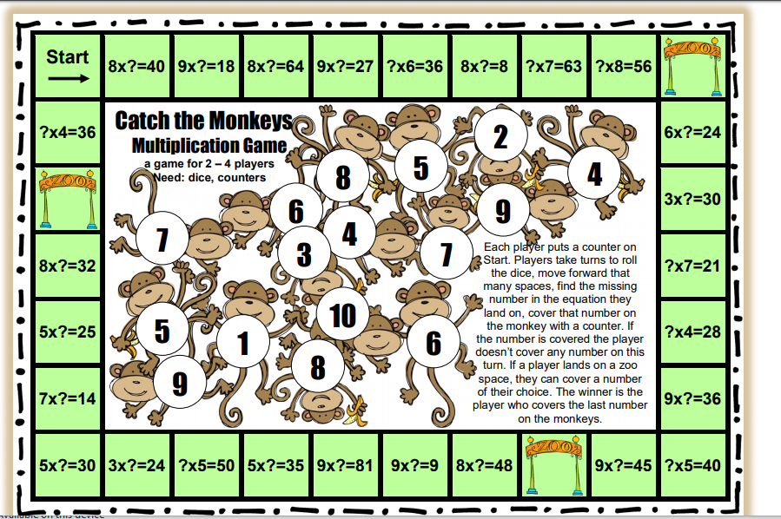

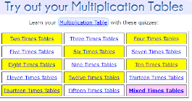
OPTION B- You select the facts you need to practice https://www.mathsisfun.com/timestable.html

Activity 2- Logic Fun
Part A-Which Pot will Fill Up First? (click and drag the picture so you can get a good look at all the options)

Part B-Find the Mystery Number
Can you solve the Puzzle to find the Mystery Word?

Operations Practice: Work out each question on loose-leaf
(Don’t forget to use Standard Algorithm Rules we covered in class together- I have included more notes – Look for “Multiplication Double Digit Algorithm Review” below)
Try these on loose leaf
1) 19 x 39 = Estimate_________ Actual: _________
2) 22 x 11 = Estimate___________ Actual: _________
3) 98 x 48 = Estimate _________ Actual: _________

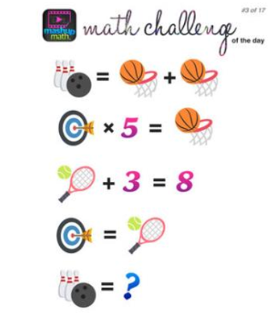
Problem of the Week: Find the value of the Bowling Ball
Extension Activity – “Build Your Own Playground” (See attachment)
